**HEALTH INSURANCE DATABASE SYSTEM**

**Milestone #3**

Group 23

ARYAK BODKHE

SHREYANS THESIA

bodkhe.a@northeastern.edu [thesia.s@northeastern.edu](mailto:thesia.s@northeastern.edu)

**Submission Date: 12/02/2022**

**Query1:**

**This query will output the patient name whose insurance has been passed along with their insurance ID and which insurance type they have bought and the amount of money which is insured to them.**

**Query 2:**

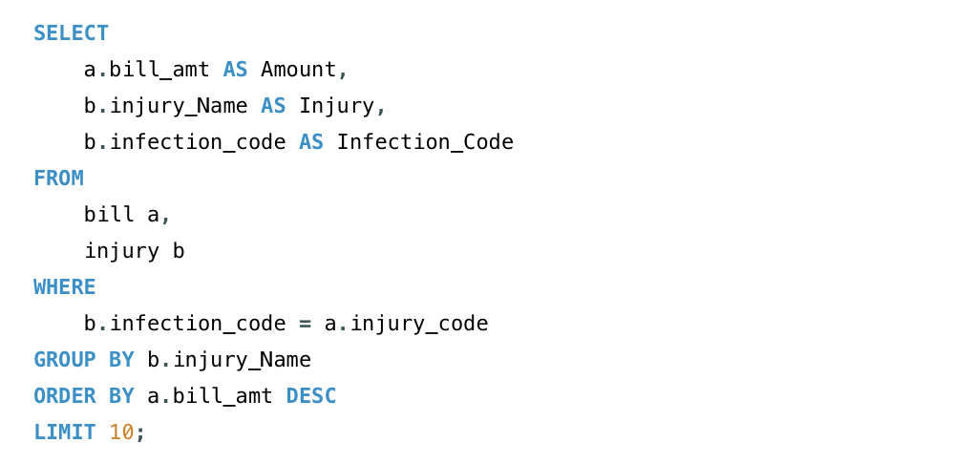

**This query outputs the injuries and the infection code which has the highest bill amount to treat that disease or injury.**

**Query 3:**

**Query to retrieve the count of hospitals in Massachusetts that are under the insurance, and which are not under the insurance.**

**Query 4:**

**Query to fetch the count of hospitals that are under the insurance, and which are not under insurance and are in Boston, Massachusetts.**

**Query 5:**

**Query to return the average issued amount when the claim for the insurance is accepted**

**Query 6:**

**Query to fetch Patient information who were treated in Hospitals in Boston and had their insurance covered along with the injury and infection code that were treated in those hospitals.**

**Query 7:**

**Query to output the count of person who has active health insurance.**

**Query 8:**

**Query to fetch the top 10 total Bill amount for the treatment of various injuries**